**Created a Warehouse named – Rejoice Warehouse**

**Created a Lakehouse named – Rejoice Lakehouse**

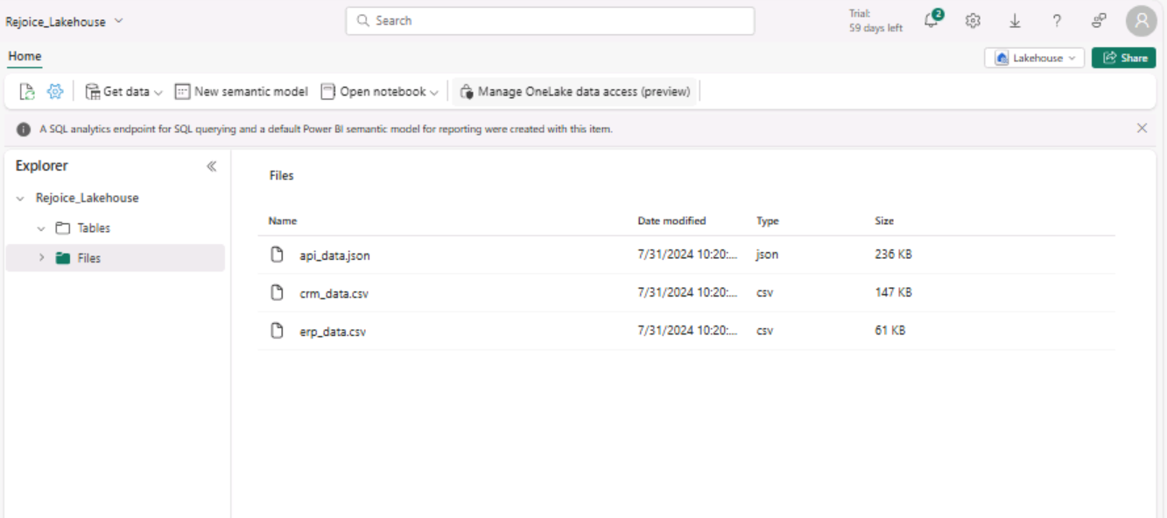

**Schema prepared in Tables of Lakehouse.**

**Data Validation for CRM_DATA**

**Data Validation for ERP_DATA**

**Changed First Row to Column Headers**

**Preparing the semantic Model**

**ERP BI Report**

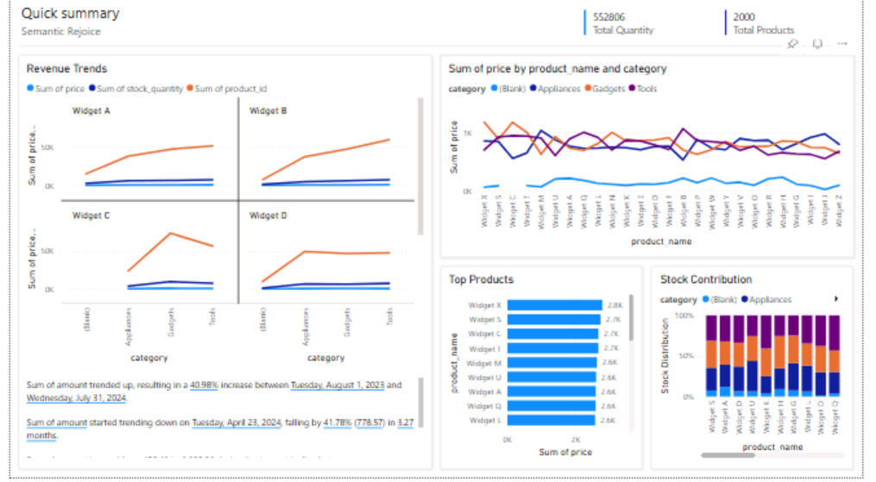

**CRM BI Report**

**Final Workspace**

